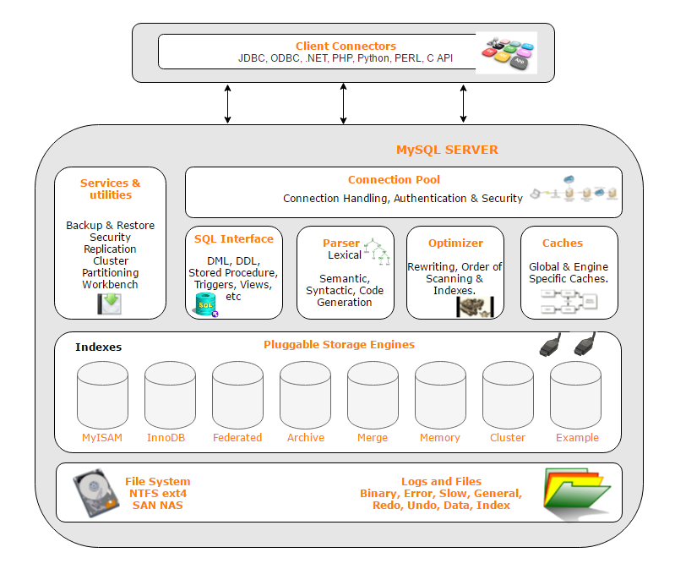

1. DML – Data Manipulation language – (Insert, Update, Delete, Merge, Call, Explain Plan, Lock)

2. DDL – Data Definition Languages – (Create, Alter, Drop, Rename, Truncate, Comment)

3. DQL – Data Query Languages - (select)

4. DCL - Data Control Languages – (Grant, Revoke)

SQL Commands

These are the some important SQL command:

* **SELECT:** it extracts data from a database.
* **UPDATE:** it updates data in database.
* **DELETE:** it deletes data from database.
* **CREATE TABLE:** it creates a new table.
* **ALTER TABLE:** it is used to modify the table.
* **DROP TABLE:** it deletes a table.
* **CREATE DATABASE:** it creates a new database.
* **ALTER DATABASE:** It is used to modify a database.
* **INSERT INTO:** it inserts new data into a database.
* **CREATE INDEX:** it is used to create an index (search key).
* **DROP INDEX:** it deletes an index.

<https://github.com/joelsotelods/sakila-db-queries>

<https://www.w3resource.com/mysql-exercises/>